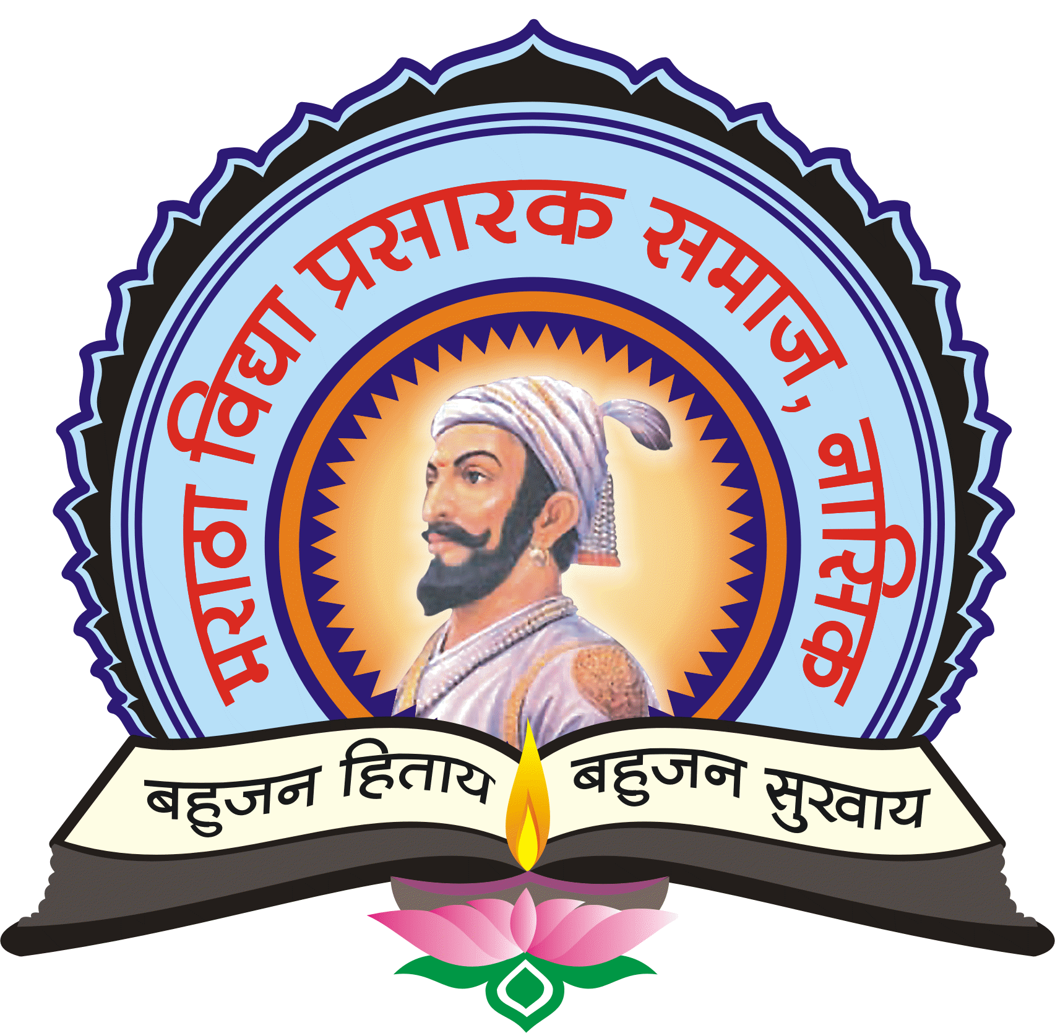
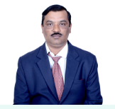

Maratha Vidya Prasarak Samaj’s
Arts, Science and Commerce College Ozar(MIG)


ABOUT ME

- Crea




Dr.Dnyaneshwar S. Borade

9923750465

Dsb14@rediffmail.com

Ozar (Mig) Nashik

CONTACT INFO


EDUCATIONAL QUALIFICATION

Sr. No. | Degree | subject | University | Passing year
1 | B.Sc. | Botany | Pune | 1995
2 | M.Sc. | Botany | Pune | 1997
3 | B.Ed. | Math’s/Science | Pune | 1998
4 | M. Phil | Botany | YCMOU Nashik | 2009
5 | Ph.D | Botany | NMU Jalgaon | 2016


WORK EXPERIENCE
WORK EXPERIENCE
DESIGNATION-
Assistant Professor In Botany
a
Sr.No. | Name of the College | Period | Designation
1 | K.S.K.. College Cidco,Nashik | 1999-2003 | Lecturer
2 | K.G.D.M.Arts Commerece and science college Niphad,Nashik | 2003-2007 | Lecturer
3 | K.A.A.N.M.S.Arts Commerece and science college Satana | 2007-2014 | Assit. Prof.
4 | Arts Commerece and science college Ozar(MIG) | 2014 to til date | Assit. Prof.

AREAS OF INTERSET/ SPECIALIACTION-Botany

Sr no | Subjects | Class
1 | Paper-I Fundamental Botany, Plant Morphology Term –I &II | F.Y.B.Sc.
2 | Paper-II- Industrial Botany Term- I & II | F.Y.B.Sc.
3 | Paper –III Practical’s in Botany | F.Y.B.Sc
4 | BO-211 Paper- I (Seme-I) Taxonomy Of Angiosperm | S.Y.B.Sc.
5 | BO-212 : Paper-II (Seme-I) Plant Physiology | S.Y.B.Sc.
6 | BO-221 : Paper-I–(Seme-II)) Plant Anatomy | S.Y.B.Sc.
7 | BO-222 Paper-II-(Seme-II) Plant Biotechnology | S.Y.B.Sc.
8 | BO-432 Paper-III Practical’s in Botany | S.Y.B.Sc.
9 | Environmental Awareness | S.Y.B.Sc.

WORKING COMMITTEES
RESEARCH PAPER /BOOKS INFORMATION
RESEARCH PAPER /BOOKS INFORMATION
AWARDS AND ACHIEVMENTS

WORKING COMMITTEES
RESEARCH PAPER /BOOKS INFORMATION
AWARDS AND ACHIEVMENTS

Sr.No. | Name of The Committee | Designation
1 | Admission Committee | Chairman
2 | Extension Programme - National service Scheme | Chairman
3 | Red Ribbon Club club | Chairman
4 | College Campus Development Committee | member

Year | Title of Paper /Books | Name Of Journal | ISSN/ISBN/NO
2013-14 | Diversity of Fungi From Pravara River at Sangamner, Ahamednagar, Maharashtra: The Genus Annulatascus | Indian Journal of Research studies (IJORS) In Pure &Applied Science | ISSN:2321-1695  (Print)
2014 | Freshwater Higher Fungi Ahamednagar District M.S. (India)-I: The Ascomycetes, Annulatascus. | Perspective in Life Science | -ISBNNO-978-81-929124-0-0
2015 | Freshwater Higher fungi from Maharashtra-II Ascomycetes | ISRJ-Weakly sciences Research Journal | 1.4210 (UIF) ISSNNO.2321-7871.
2015 | Freshwater Higher fungi from Maharashtra-I-Ascomycetes | Science Park Research Journal | 1.6200  (UIF2013
2016 | Freshwater Higher Fungi Ahamednagar M.S.(India)-II: District The Ascomycetes, | IJRBAT-International Journal Research In Bioscience Agriculture &Technology | ISSNNO-2347-517X
Dr.D.S.Borade2017 | Freshwater and Marine fungi of India | Dec-2017 | ISSN:978-620-2-05122-4
2018 Feb | Diversity of Freshwater Fungi Ahamednagar District M.S.: Ingoldian Fungi. | IJRBAT-International Journal Research In Bioscience Agriculture &Technology | ISSNNO-2347-517X
Research Project Completed
.
In Last Three Years 2015 – 2016, 2016-17,2017-18. Dr. Borade D.S. Assistant professor
in Botany received Best Programme Officer Award by Datyane Grampanchayat, Datyane .

About Me
- M.Sc. in Botany (1995)
- B.Ed Math / Science.(1998)
- M.Phil . Botany (2009)
- Ph.D.in Botany Aquatic Fungi(2016)
- N.S.S. Programme Officer ( since 2015-16)
- N.S.S. Regional Co-Ordinator in Niphad Taluka (since 2015-16)
- Area of Specialization –Phycology, Aquatic Mycology
- Teaching at UG/PG level from 1999 (20 Years)
- 15 Research Papers published in International journals.
- Three paper presented in International Conference
- Member of College Examination Committee , Ozar(MIG) (2014-16)
- Chairman ,First Year Admission Committee at Ozar College.
- Worked as External Examiner in Various Colleges appointed by SPPU
- Organized a Blood Donation Camp at Ozar College on June 2015
- Worked as member of Squad Committee appointed by SPPU
- Co-coordinator - One Day Regional level Workshop on Voters Awareness Programme.
- Co-coordinator - One Day District level Workshop on Female Foeiticide Programme.
- Member, College Campus Development Committee. in College Ozar (MIG) (2014-15)
- Election Booth PRO at Lokshaba Vidhansabha Assembly, Grampanchayat Election.
- Organized in the Swachhayata Hich Seva Abhiyan in Ozar , Datyane, Grampanchayat
- Arranged a Poster- Presentation at N.S.S. Camp at Datyane.
- Arranged Programs on Road Safety Abhiyan Adopted Village Datyane
- Arranged Workshops on Disaster management Flood At Chandori School
- Organized a N.S.S Special winter Camp at Adopted Village Datyane (2014-17)
- Organized a Voters’ Awareness Rally & Training Programme in 25 Jan Every Year at Ozar College
- Organized a Rally on Save Water Save Fuel at Ozar (Mig)

RESEARCH PAPER /BOOKS INFORMATION
Year | Titale of Paper /Books | Name Of Journal | ISSN/ISBN/NO
2013-14  DSB | Diversity of Fungi From Pravara River at Sangamner, Ahamednagar, Maharashtra: The Genus Annulatascus | Indian Journal of Research studies (IJORS) In Pure &Applied Science | ISSN:2321-1695  (Print)
2014 | Freshwater Higher Fungi Ahamednagar District M.S. (India)-I: The Ascomycetes, Annulatascus. | Perspective in Life Science | -ISBNNO-978-81-929124-0-0
2015 | Freshwater Higher fungi from Maharashtra-II Ascomycetes | ISRJ-Weakly sciences Research Journal | 1.4210 (UIF) ISSNNO.2321-7871.
2015 | Freshwater Higher fungi from Maharashtra-I-Ascomycetes | Science Park Research Journal | 1.6200  (UIF2013
2016 | Freshwater Higher Fungi Ahamednagar M.S.(India)-II: District The Ascomycetes, | IJRBAT-International Journal Research In Bioscience &Technology | ISSNNO-2347-517X
2017 | Freshwater and Marine fungi of India | Dec-2017 | ISSN:978-620-2-05122-4
2018 Feb | Diversity of Freshwater Fungi Ahamednagar District M.S.: Ingoldian Fungi. | IJRBAT-International Journal Research In Bioscience Agriculture &Technology | ISSNNO-2347-517X

Thanks & Regard

