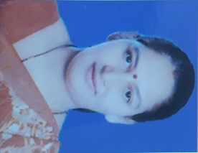
Dr. Vaibhavi Prashant Patil

74, “Shivneri”, Bapu Nana Colony, Khode Nagar, Wadala Shivar, Nashik- 422006
E: vaibhavippatil06@gmail.com T: 9422774667/8329507802

OBJECTIVES:

To work with a reputed institution as Assistant professor, that will provide me a good platform to utilize my teaching & administration skills and will help me to grow my career.
EDUCATIONAL QUALIFICATION:

Doctor of Philosophy; Limnology and Biodiversity Studies of Algal Flora of Sulwade Barrage of Dhule District, North Maharashtra University; Jalgaon (2009-14)

M.Phil; Ecobiodiversity of Algae from Amravati Dam in Dhule District;
North Maharashtra University; Jalgaon (2008)

Masters of Science (Botany); North Maharashtra University; Jalgaon (1996)

Bachelors of Science (Botany); North Maharashtra University; Jalgaon (1994)

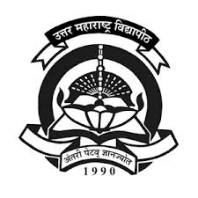

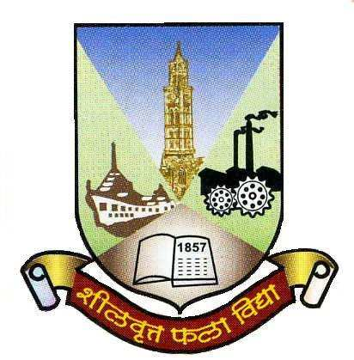

Masters of Education (M.Ed.), University of Mumbai (2017)

Bachelors of Education (B.Ed.), University of Mumbai (2000)

RESEARCH EXPERIENCE:

Ph.D. Limnology and Biodiversity Studies of Algal Flora of Sulwade Barrage of
Dhule District.
Flora flourished on the based on physico-chemical factor of water. Water samples collected in every month for 24months. Analyzed the pattern and Biodiversity of algal flora.

M.Phil. Ecobiodiversity of Algae from Amravati Dam in Dhule District.
Studies exact dimensions of algal taxa with the help of Camera Lucida.

M.Ed. Dissertation on A Study of secondary school teacher decision making in relation
to their job satisfaction
PROFESSIONAL EXPERIENCE:

Currently working as Assistant Professor in Botany at MVP’S Arts, Science & Commerce College Ozar (Mig)

- Assistant Professor 2018- (Current) K.K.Wagh Arts, Commerce, Science & Comp. Science College, Chandori (Nashik)
- Working as a NAAC Coordinator
- Analyzed the Physico-chemical parameters of water samples collected from nearby areas.
- External practical examiner for UG students.
- Given the guidance to student for preparation of annual examination.

- Assistant Professor 2014-16 Bramha Valley Arts, Commerce and Science College
- Worked as NSS Coordinator
- Bahishal Sikshan Mandal Coordinator
- Evaluated and revised the course content, course materials and methods of instructions.
- Used ICT for better understanding of the student
- Evaluate and grade students’ class work assignments and papers
- Worked as a guide for student’s dissertations

- Jr. Lecturer 2008-09 Gokhale Education Society’s NGKG Jr. College, Borivali
- Used interactive method of teaching-learning for the fresher students.
- Conducted the lecture on environmental awareness.
- Worked as an external examiner.

- Jr. Lecturer 2004-05 Chate Coaching Classes
- Taught plant morphology for 12th class student.

SKILLS

- Subject Taught: Taxonomy of Angiosperm,
Plant Morphology and Anatomy,
Industrial Botany
- Professional : MS Office

RESEARCH ACTIVITIES:

Patil V.P. and Nandan, S. N. (2012) “Hydro Biological Studies on Algal Flora of Sulwade Barrage of Dhule District” Maharashtra, India. Biotechnology and environmental Crisis: Past, Present and Future, pp. 177-179.

Patil V.P., and Nandan, S. N. (2011) “Biodiversity of Cyanophyceae from Amaravati Dam of Dhule District” Maharashtra, India. Journal of Experimental Science, Vol.2, No.3, pp. 33-36.

Nandan, S. N., Pawar, M. D. and Mahajan, K. D. (2007). “Studies on din tony flora of North Maharashtra region Genus Pinnalaria in NA.SY.” On Recent Trends in algal Biotechnology and Biodiversity, Vol.1 No.2.

Nandan, S. N., and Pawar M.D. (2007). “A Systematic Account of the diatoms from Amaravati Dam of Dhule District.” Maharashtra, India. Journal of Environ and Ecoplan, Vol. 4, No. 3, pp. 591-600.

Nandan, S. N., and Pawar M.D. (2007). “Studies on the Physico-Chemical and Algal flora of Lentic Hydrosphere of Amravati Dam of Dhule District” Maharashtra, India, Oikoassay: An International Journal of Experimental Science, Vol. 20, No. 1-2.
PARTICIPATION IN WORKSHOP:

January, 30-31, 2009 “Advances in Genetics & Molecular Biology” Seminar Organized by Department of Botany, HPT Arts & RYK Science College, Nashik-5.

February 19-21, 2007 DAE-BRNS- National Symposium on Limnology (NSL-07) held at College of Fisheries MPVAT, Udaipur.

